

217, Sheikh Rashid Building

P.O Box 56272, Dubai

United Arab Emirates

Tel: +971 4 2973236 / 04 2974007

Email: [uae@verbat.com](mailto:uae@verbat.com)

PROJECT   
PROPOSAL

**Development of Task Management System**

|  |  |
| --- | --- |
| **Prepared for:**  **Ministry of Infrastructure Development (MOID)** Hessa Al Suwaidi  IT Manager  [Hessa.alsuwaidi@mopw.gov.ae](mailto:Hessa.alsuwaidi@mopw.gov.ae) | **Submission Date:**  14 Feb 2017  **Proposal ID:** SW/12122016/1245/1 |

___________________________________________________________________________________________________________________________________________  
Conﬁdentiality Notice: This Proposal is conﬁdential and contains proprietary information and intellectual property of Verbanet Technologies LLC. Neither this proposal nor any of the information contained herein may be reproduced or disclosed under any circumstances without the express written permission of Verbanet.

© 2017 by Verbanet Technologies LLC. All rights reserved. Confidential.

___________________________________________________________________________________________________________________________________________

Project Contacts

|  |  |
| --- | --- |
| Client Information | |
| Project Name | Task Management System |
| Client Name | Ministry of Infrastructure Development (MOID) |
| Client Address | Al-Nahda Street  Opposite to A l- Nahda Metro Station  Al Qusais |
| Phone Number | +971 42610001 |
| Contact Person | Hessa Al Suwaidi  IT Manager |
| Contact Person Email | Hessa.alsuwaidi@mopw.gov.ae |
| Contact Person Phone Number | +971 503388838 |
| Contact Person Fax Number | +971 42125725 |
| Verbat Information | |
| Contact Person | Joyce Daniel |
| Contact Person Phone Number | +971 4 2973236 |
| Contact Person E-Mail | Joyce.daniel@verbat.com |
| Address | PO Box 56272, Dubai |
| Physical Address | 217, Sheik Rasheed Building Hor Al Anz East, Dubai |
| Project Information | |
| Proposed Technology/Methodology | Microsoft .Net Technology |
| Anticipate Start Date | NA |
| Proposal Valid For | 30 Calendar days from the submission of the proposal |

**Table of Content**

1 Executive Summary 5

1.1 Solution Objective 6

1.2 Advantages of Proposed Solution 8

1.3 Why Verbat 8

1.4 Key Differentiators 9

1.5 Underlying Support Services 10

2 Functional Specification 11

2.1 Phase 1 11

2.1.1 Application Login 11

2.1.2 Project workspace (Partial) 11

2.2 Phase 2 12

2.2.1 Project Work Space (Intermediate) 12

2.3 Phase 3 12

2.3.1 Project Work Space (Advanced) 12

2.4 Phase 4 12

3 Project Scope 13

4 Solution Overview 15

5 Application Workflow 16

6 Application Functionality 17

7 Assumptions 18

8 Out of Scope 18

9 Technology Solution 19

9.1.1 Web Application 19

9.2 Technical Configuration 19

9.2.1 Technical Guidelines 19

9.2.2 Development Tools 20

9.2.3 Minimum Server Specification for Application Hosting 20

9.2.4 Browser Compatibility for Application 20

9.2.5 Hardware Interface 20

10 Delivery Management 21

10.1 Project Management 21

10.2 Roles and Responsibilities 21

10.3 Phase Delivery Activity summary 22

10.4 Project Implementation plan 22

10.5 Deliverables 22

10.6 Deployment Details 23

10.7 Release Planning 23

10.8 Risk and Contingency planning 23

11 Change Management 25

12 Project Effort & Timeline 26

12.1 Effort Estimate overview 26

12.2 Effort Estimate Phase 1 27

12.3 Effort Estimate Phase 2 28

12.4 Effort Estimate Phase 3 29

12.5 Effort Estimate Phase 4 30

13 Commercial 31

14 Miscellaneous 32

14.1 Warranty 32

14.2 Acceptance Criteria 32

14.3 General Terms and Conditions 32

14.4 Assumptions and Dependencies 33

14.5 Source Code & Intellectual Property Rights 33

15 Our Clients 35

# Executive Summary

MeServices (here after referred to as “Client”), a Leading services company working in the field of recruiting, outsourcing and other services has requested Verbat Technologies to implement two new Portals; one for the development of an employee self-service portal and a recruitment portal that is both public facing (internet) as well as employee facing (intranet).

The Employee Self Service Portal shall be used by the client’s employees to ease communication and collaboration with the HR and Financial system so as to save time and achieve high employee satisfaction. The system shall be integrated with the client’s existing ERP.

The Recruitment portal is both a public facing as well as an employee facing portal.

The intranet portal is an application that that can handle different type of employees' contracts, business unit structure, employee pay scale and HR policy which would include the benefits and leaves entitled for the employees. Additionally the application allows companies to create an account and advertise their job vacancies, handle hiring cycles etc.

The public facing portal list job vacancies retrieved from the client’s ERP Recruitment Module. Users can register on the website and apply for jobs. Other standard features include ability to view application history, upload CV’s, advertise new job openings etc.

Web based Application Development is an area where Verbat has in-depth knowledge and expertise. Being the pioneers in Custom solutions across the major verticals, we are sure to help you enhance your team engagement to drive differentiation. We bring proven methodologies and processes, global expertise in application development, and a legacy of best practices and ready-to-fit frameworks to expedite the development cycle and reduce the total cost of ownership.

Verbat is pleased to have received the request to submit the proposal and values it as a great opportunity to have a long term & mutually beneficial association with the client. Verbat has gone through the requirement and presents a technical & commercial proposal for the requested system. With the focus of delivering value to client, Verbat proposes a managed solution model for this requirement.

Verbat Technologies is uniquely qualified to help client to build this application, due to our:

* + Strong and established presence in the Middle East over a decade
  + Team of expert consultants, Innovative and experienced resources
  + Technical know-how with Microsoft Technology systems helping clients achieve strategic business goals
  + Proven record of executing strategic, high-level projects for large, diverse and dispersed audiences

## Solution Objective

The client has contacted Verbat Technologies to develop a web based application to ease their employees’ communication and collaboration with the HR and Financial system to save time and achieve high employee satisfaction. Additionally an Intranet and internet application needs to be developed to handle their recruitment process

To manage the development of the application, Verbat will split the development into **three phases**, with the objective of delivering a minimum viable project in Phase 1 followed by an incremental approach to deliver the complete product.

**The main features of the application are listed below:**

|  |  |
| --- | --- |
| **Employee Self Service Portal**   * Access employees profile * Manage employee non critical data * Have an approval cycle to verify the employee information modification * Allow employee to create request for leave * Allow managers to approve the leave * Update the HR (ERP) system with the new approved leaves * Send notification to the employee regarding the leave request status * Follow up on his leave request * Request for salary certificate * Request for purchase * Allow the workflow of approvals for the purchase request * Update the procurement (ERP) system with the approved purchase requests * Send notification regarding the purchase request status to the employee * Timesheet/attendance view * Employee evaluation sheets shall be done through the portal * Receive expense claims * Integration with the HR and Payroll to retrieve information about the employee.   **Internet Recruitment Portal**   * Job seeker Registration * List of available jobs for the job seeker * Upload CV and update profile for the job seeker * View history of applied job * Apply for job * Search for jobs * Employer Registration * The employer can create a new job * View list of his created jobs * View list of candidates who have applied for his jobs * Based on employer registration type he can view list of job seekers resumes. * Online payment for the job seeker to upgrade his registration type. * In case of jobs that is posted by MeServices, it shall be integrated into the recruitment system in the ERP | **Intranet Recruitment Portal**   * Handle different companies * Handle jobs and vacancies for different companies * Ability to set different hiring process/workflow for each company * Ability set different screening and selection criteria for each company's job * Ability to manage the received candidate's information. * Should allow/have document management facility to store candidate's documents. * Handle the interview cycle with different workflow based on the job conditions and company * Allow a smart search and analytics for existing resumes. * Handle the hiring cycle * Give notification for next actions to be taken * Have KPIs for the recruiters performance * Integrate with email * Should give alerts for companies contract needs that are below their threshold. * Powerful reporting module   **Data Migration**   * Data migration from Oracle E-Business Suite (ERP) * Data migration from MECourier * Data migration from Taresh   **Additional Features common to all modules**   * Ease of use * Reports * Customizable dash boards * Customizable workflows * Easy integration with email client * Easy integration with our ERP * Easy integration with Microsoft Excel * Ability to access the system from any location * The ease to integrate with existing systems * Audit trails shall be available |

Verbat’s Solution architects have conducted a thorough research on the requirements and have come to the conclusion that our proposed solution, which is detailed further in this document, will meet the requirements put forth by the client. The proposed solution will be delivered in a phased approach as per Verbat‘s managed solution model.

**Strong and Scalable platform:** The platform proposed will be strong and scalable enough to accommodate future enhancements.

**Accelerated solution:** The framework would act as a solution accelerator. It would provide the basic building blocks which could be reused in future for building new components and features.

**High performance:** The light weight framework used consumes fewer system resources thereby making the application perform faster.

**Security:** The application will be developed considering various aspects of security

## Advantages of Proposed Solution



01

Agile development offering reliable, scalable and secure solution

02

Smooth transition and quicker completion of processes

03

User friendly interfaces enabling easy navigation between screens

## Why Verbat

Globally Accredited

Software Consultation Partner

Spearheaded by a   
team of Technology and   
Management Leaders



Over 16+ years of customer experience with Global   
Corporations

Service in Banking, Retail, Logistics, Construction & Contracting, Fashion, Manufacturing, Hospitality, Automotive, Healthcare and Government sectors

IT Strategy, Application Development and Maintenance, Testing Services, Information Management and Digital Marketing efforts



## Key Differentiators

Delivered digital transformation expertise to global customers for over a decade by following industry best practices to maximize ROI for client

Keen technology intelligence combined with aggressive market research to deliver solutions that achieve results with measurable value

Enable access to global consulting expertise with strong local market and business knowledge

Commercial Model that is customizable for your business needs

Reuse of code libraries for Rapid Application Development

1,000,000 plus man-hours of expertise in technology frameworks spanning Microsoft, Open Source, mobility platforms and other proprietary IT technology

Partners top technology vendors to bring in the latest and best services in integration, collaboration, and development

Commercial Model that is customizable for your business needs

Proven Methodologies & Processes

Investment in R & D

Strong Local Presence

Flexible commercial Models

Technology Associations

Code Repository

Software Development Experience

Offshore Development Centre

## Underlying Support Services

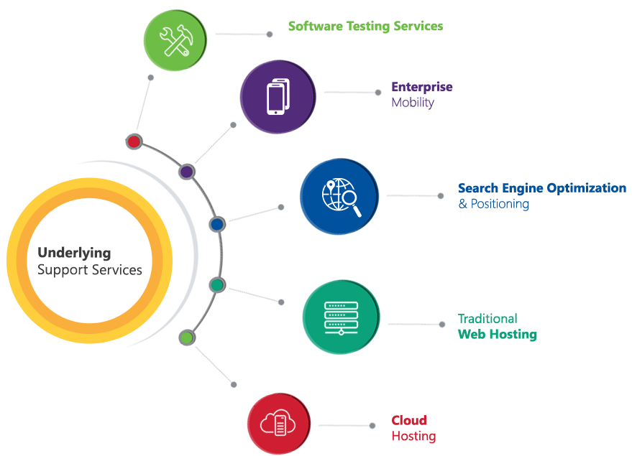

# Functional Specification

To manage the development of the application, Verbat will split the development into **four phases**, with the objective of delivering a minimum viable project in **Phase 1** followed by an incremental approach to deliver the complete product:

## Phase 1

### System Features

* Customizable dash boards
* Integration with email client
* Integration with Microsoft Excel
* Ability to access the system from any location
* integration with existing systems
* Audit trails shall be available

### Employee Self Service Portal

* Access employees profile
* Manage employee non critical data
* Have an approval cycle to verify the employee information modification
* Allow employee to create request for leave
* Allow managers to approve the leave
* Update the HR (ERP) system with the new approved leaves
* Send notification to the employee regarding the leave request status
* Follow up on his leave request
* Request for salary certificate
* Request for purchase
* Allow the workflow of approvals for the purchase request
* Update the procurement (ERP) system with the approved purchase requests
* Send notification regarding the purchase request status to the employee
* Timesheet/attendance view
* Employee evaluation sheets shall be done through the portal
* Receive expense claims
* Integration with the HR and Payroll to retrieve information about the employee.

## Phase 2

### Internet Recruitment Portal

* Job seeker Registration
* List of available jobs for the job seeker
* Upload CV and update profile for the job seeker
* View history of applied job
* Apply for job
* Search for jobs
* Employer Registration
* The employer can create a new job
* View list of his created jobs
* View list of candidates who have applied for his jobs
* Based on employer registration type he can view list of job seekers resumes.
* Online payment for the job seeker to upgrade his registration type.
* In case of jobs that is posted by MeServices, it shall be integrated into the recruitment system in the ERP

## Phase 3

### Intranet Recruitment Portal

* Handle different companies
* Handle jobs and vacancies for different companies
* Ability to set different hiring process/workflow for each company
* Ability set different screening and selection criteria for each company's job
* Ability to manage the received candidate's information.
* Should allow/have document management facility to store candidate's documents.
* Handle the interview cycle with different workflow based on the job conditions and company
* Allow a smart search and analytics for existing resumes.
* Handle the hiring cycle
* Give notification for next actions to be taken
* Have KPIs for the recruiters performance
* Integrate with email
* Should give alerts for companies contract needs that are below their threshold.
* Powerful reporting module

### Data Migration

* Data migration from Oracle E-Business Suite (ERP)
* Data migration from MECourier
* Data migration from Taresh

# Project Scope

|  |
| --- |
| Employeee Self Service Portal |
| Project Plan (WBS, Sched mgmt plan, Comm plan, FS , SRS) |
| Finalising and purchase of HTML Theme & Images |
| Complete running & approved prototype |
| ADMIN |
| Approximately 10 master setting pages |
| Login |
| Employee registration |
| Customizable Dashboards |
| Workflows |
| Audit Trail |
| Access employees profile |
| Manage employee non critical data |
| Have an approval cycle to verify the employee information modification |
| Allow employee to create request for leave |
| Allow managers to approve the leave |
| Update the HR (ERP) system with the new approved leaves [Require APIs and the documentation] |
| Send notification to the employee regarding the leave request status |
| Follow up on his leave request |
| Request for salary certificate |
| Request for purchase |
| Allow the workflow of approvals for the purchase request |
| Update the procurement (ERP) system with the approved purchase requests[Require APIs and the documentation] |
| Send notification regarding the purchase request status to the employee |
| Timesheet/attendance view |
| Employee evaluation sheets |
| Receive expense claims |
| Integration with the HR and Payroll to retrieve information about the employee.[Require APIs and the documentation] |
| Testing and QA |
| UAT & GoLive |
| Total |
| Recruitment Portal (Intranet) |
| Project Plan (WBS, Sched mgmt plan, Comm plan, FS , SRS) |
| Finalising and purchase of HTML Theme & Images |
| Complete running & approved prototype |
| Customizable Dashboards |
| Customizable Workflows |
| Audit Trail |
| Handle different companies (Add different companies) |
| Handle jobs and vacancies for different companies |
| Ability to set different hiring process/workflow for each company |
| Ability set different screening and selection criteria for each company's job |
| Ability to manage the received candidate's information. |
| Should allow/have document management facility to store candidate's documents. |
| Handle the interview cycle with different workflow based on the job conditions and company |
| Allow a smart search and analytics for existing resumes. |
| Handle the hiring cycle |
| Give notification for next actions to be taken |
| Have KPIs for the recruiters performance |
| Integrate with email |
| Should give alerts for companies contract needs that are below their threshold. |
| Powerful reporting module |
| Testing & Bug fixing |
| UAT & GoLive |
| Total |
| Recruitment Public Portal |
| Project Plan (WBS, Sched mgmt plan, Comm plan, FS , SRS) |
| Finalising and purchase of HTML Theme & Images |
| Complete running & approved prototype |
| Customizable Dashboards |
| Customizable Workflows |
| Audit Trail |
| Job seeker Registration |
| List of available jobs for the job seeker |
| Upload CV and update profile for the job seeker |
| View history of applied job |
| Apply for job |
| Search for jobs |
| Employer Registration |
| The employer can create a new job |
| View list of his created jobs |
| View list of candidates who have applied for his jobs |
| Based on employer registration type he can view list of job seekers resumes. |
| Online payment for the job seeker to upgrade his registration type. |
| In case of jobs that is posted by MeServices, it shall be integrated into the recruitment system in the ERP [Require APIs and the documentation] |
| Testing & Bug fixing |
| UAT & GoLive |

# Solution Overview

* Security and user management services to Create users, User logins, Invite users and Create teams
* Workflow services to manage the task status
* Notification services to send emails to invite users, task notifications for pending tasks, Overdue and completed tasks
* Data storage on compatible RDMS database
* File attachments for tasks, projects and folders stored in a secure file system

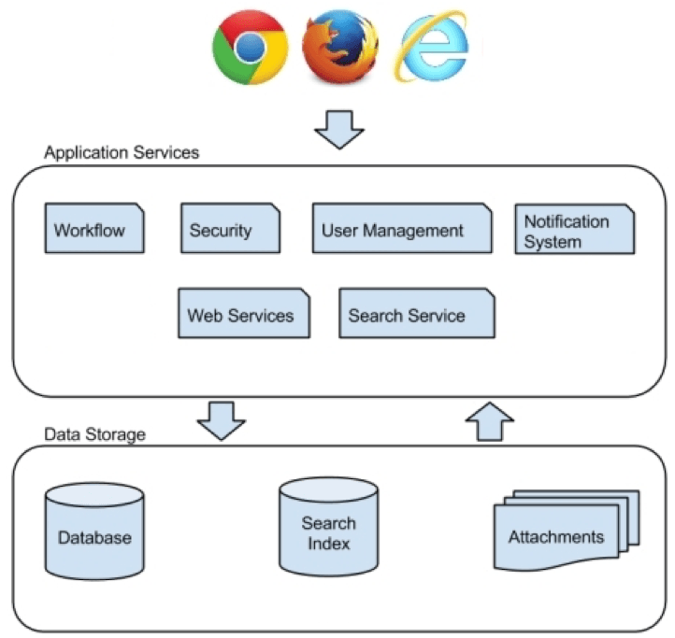

# Application Workflow

* Admin Creates Projects & invites users
* Users are assigned roles
* Admin and users can create tasks and subtasks
* Tasks can be scheduled and assigned to users or teams
* Tasks can have a description, attachment & comments
* Users update the task status upon completion of the job
* Reports on team & project performance
* Users communicate with each other using dashboards, Inbox & Task Assignment

# Application Functionality

## Self Service PortalC:\Users\v10030\Downloads\EmployeeSelfService.png

**Employers can**

1. Login
2. Approve profile updates
3. Approve leave request
4. Approve equipment purchase
5. Approve expense claims

**Employees can**

1. Login
2. Update their profile
3. Request for leave
4. Request for salary slip
5. Request equipment for purchase
6. Request expense Claims
7. Mark their attendance

## Intranet Recruitment Portal

C:\Users\v10030\Documents\proposal\Meservices\IntranetRecruitmentPortal (1).png

**Intranet Application that can**

1. Register Companies
2. Register candidates
3. Register Jobs
4. Search for Candidates
5. Filter candidates based on screening & selection criteria
6. Have a custom interview cycle based on a per company basis
7. Have a custom hiring workflow per company
8. Integrated email to receive updates for new jobs, new candidates & new companies
9. Mark KPI’s for recruiters

C:\Users\v10030\Documents\proposal\Meservices\InternetRecruitmentPortal (1).png

**Internet application that**

1. Has login for Job seekers and Employers
2. Job seekers can register and upload their CV’s to create their profile
3. Employers can register and post new jobs
4. Job seeker and employer can upgrade their registration with an online fee payment
5. Job seekers can view their application history
6. Job Seekers can search and apply for jobs
7. Employers can view their list of jobs created as well as the candidates who applied for a job
8. Employees that have been added via the ERP application will be integrated to the website using API calls to the ERP system

# Assumptions

The project solution and technology is created from the initial understanding of the requirement shared with Verbat through mails and meetings. The proposed solution is based on the following assumptions:

* Requirements should be well defined, agreed and signed-off by the client
* Client shall provide the required access for the deployment of the developed application
* The application shall follow a phase wise development
* The application interface will be using English language
* The client shall provide the branding guidelines
* Client shall provide licensed images and logos in specified size & format

# Out of Scope

The requirement needs should be clear to both the parties involved, hence the importance of mentioning the out of scope details of the project. Following are considered to be out of scope while creating this proposal.

* Any language other than English
* Adding new features to the application other than mentioned in this proposal
* Manual data entry
* Purchase of images, fonts
* Database migration
* Hosting, Backup solution and Disaster recovery for web hosting
* Content writing
* Annual Maintenance Contract

# Technology Solution

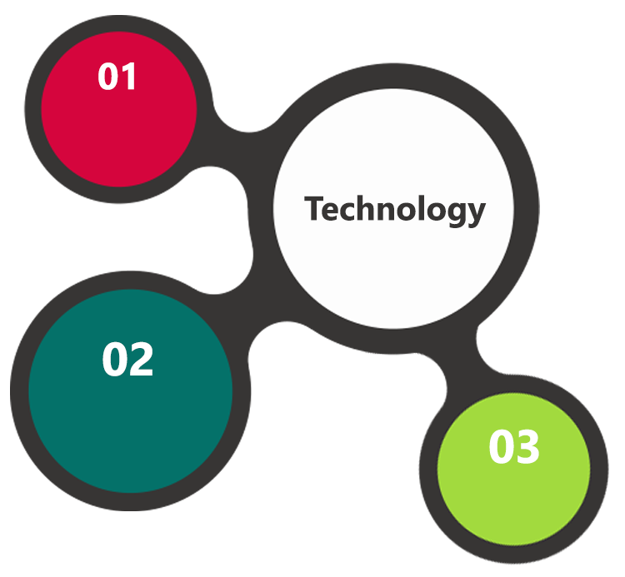

ASP.Net 4.5

MVC  
 Architecture

MS SQL 2014  
Windows 2012 OS  
IIS 8.0

HTML 5  
JavaScript  
CSS3

### Web Application

* Keeping the requirements into consideration, Verbat proposes a web application in ASP.NET for the Development Environment,
* MS SQL Server as the Database, Windows 2012 as the server operating system
* IIS 8.0 as the Web Server

## Technical Configuration

### Technical Guidelines

The guidelines provide instructions and conditions that will be adhered to during the development of the mobile application

* The client will finalize the functional requirements and wireframe/prototype before the commencement of the project
* Client should provide the root access or FTP details for deploying the application to clients server before the testing of the application starts
* The duration mentioned in the project time line is for development and testing and any delay or time taken by the review team to respond will not be Verbat’s responsibility. Any clarification required from client needs to be addressed within 24 hrs.

### Development Tools

* Visual Studio, Sublime Text 3
* MS SQL Server Management Studio & Photoshop

### Minimum Server Specification for Application Hosting

Web server should feature a combination of the following software/hardware

* Processor: Intel Xeon Quad Core, 3. 3GHz (8 threads)
* Memory: RAM 12 GB or Higher
* Operating System: Windows 2012 64bit
* HDD Quota: 120 GB
* Database Server Software: SQL 2012 Standard
* Web Server: IIS - 8. 0
* Framework: ASP. Net 4. 5

### Browser Compatibility for Application

* Chrome 56.0
* Firefox 51.0

### Hardware Interface

The application is web based, it’s not dependent on any designated hardware, and it does not have any direct hardware interfaces. But we recommend the below specification for best output.

* Computer with Windows 8 or 10 OS
* Compatible Browsers as specified in section 9.2.4

# Delivery Management

## Project Management

Verbat strictly follows industry standards on quality for development. The project management process is governed by the Verbat Quality Management system and is put to verification through internal audit programs that happen from time to time.

Verbat will dedicate a project manager for the proposed implementation. Verbat proposes Client to identify one project manager who will be driving activities to be undertaken by Client to be the single point of contact for Verbat.

## Roles and Responsibilities

Verbat will assign a dedicated Project Manager/Project Lead to lead the project, who will be the first point contact for Client. He/she will be responsible for planning and managing the various activities within the project. He/she will work closely with Client Project Manager, to give periodic status updates and ensure high level of visibility and comfort on the progress of the project.

The Project Manager/Project Lead will lead the co-ordination between Verbat and Client, thus enabling smooth transitioning of Client requirements to the Verbat’s offshore delivery team, and provide visibility as well as comfort on the progress of the services to Client.

He/she will have periodic meetings with Verbat’s Senior Management, thus ensuring Verbat’s Management commitment and focus on Client initiatives.

## Phase Delivery Activity summary

|  |  |
| --- | --- |
| Activities | Description |
| Detailed requirement Analysis | Verbat team to conduct detailed study of requirement for the phase. If clarification is required, team will reach out to Client for more information and/or time for discussions. |
| Software Requirement Specification document (SRS) | Once the requirement analysis is completed, Verbat team will submit the SRS document for approval |
| UI/UX Design, Prototyping | Based on the SRS, Verbat UX/UI team will work on the UI/UX of the screens and submit a prototype for approval |
| Functional Specification Document (FS) | Once the Prototype / UI/UX is approved, Verbat shall submit an FS document for approval |
| Development | Actual system development starts based on the FS. This involves detailed design and software development of the Web application |
| Testing | Test Planning, test plan creations, internal, integration testing and user acceptance testing. |
| Deployment | Deploying the latest built in the Verbat Test Server for UAT |

## Project Implementation plan

Verbat will be providing the solution in a phased approach which ensures minimum viable solution for quick wins with core focus on the long term business objective and outcome. Once the implementation of phase 1 is over, Verbat will initiate the application maintenance process which continues to extend after the implementation of successive phases.

## Deliverables

* Software Requirement Specification Document (SRS)
* Wire Frames for Key Screens
* HTML Prototype of the application
* Functional Specification Document (FS)
* Fully Developed & Tested Application
* Test Plans
* User Manual (English)

## Deployment Details

* Client shall provide the server FTP, Root Access of the server for Application deployment

*Client can opt for hosting the web application at Verbat’s Server. Hosting the application at Verbat’s server will call in for additional charges.*

* If deployment is at the client’s server, responsibility of deploying the delivered built or any other interim releases onto the production environment after conducting the necessary acceptance testing will lie with the client, unless and until Verbat’s support is contracted for deployment.

## Release Planning

* Client will be informed about the release date and time through email
* Client performs the UAT and Signoff

## Risk and Contingency planning

Verbat has identified various risk factors associated with this assignment and understands the impact of these risk factors on the project schedules. The objective of this section is to highlight for both Verbat and client, the risk factors, to analyse the impact of the risks on project execution, and to propose strategies to control and reduce the impact of the risk factors.

These various risks, which could arise during the project, are tabulated below along with mitigation implementation.

| Type of risk | Impact | Risk Mitigation | Risk Handling |
| --- | --- | --- | --- |
| Scope Creep | H | Functions and features will be detailed in system requirement documents and will go through client approval. Once this document is approved, any change to requirement will go through change management review for possible impact assessment. | Proper change management procedure will be implemented. |
| Delay in customer feedback | H | The plan is prepared with enough lead-time for customer reviews and approvals.  The customer is indicated with the dates when the document is expected after review and approval. | The request for feedback will be escalated if not attended at the right time so that the schedules are not affected. Deemed acceptance criterion is set up front and will be followed. |
| Non-availability of necessary software’s, frameworks, database instances and infrastructure at client’s hosting environment(If hosting support is provided by Verbat) | M | Client will be informed in advance on these requirements. | Possible impact to schedule. |
| Manpower attrition | L | All efforts would be made to ensure process dependence rather than being person dependent. As a risk mitigation plan Verbat will train backups. | A new person will be identified as early as possible, provided the required project-specific training and mentored by the senior members of the team to minimise impact of attrition on the project. |

*H-High, M-Medium, L-Low, NA-Not Applicable*

# Change Management

Any addition which comes out of the project scope, upon and after the launch of the tool will be considered as change management. Verbat recommends the following change management procedure for the same.

* Any change which comes out of the project scope, which was discussed, documented, and mutually approved by both the parties in the requirement stage, will be carried out only through raising a change request.
* Change request will be studied and an impact analysis on the existing work flow will be performed.
* On finalizing the impact, effort estimation for the change will be calculated and raised as additional requirement.
* Verbat will initiate the change request only after getting a formal approval from the client for the additional changes raised.
* Any change from the scope will be charged at **AED 1,200 per man day effort** and approval from the clients will be availed before commencing on any change management.

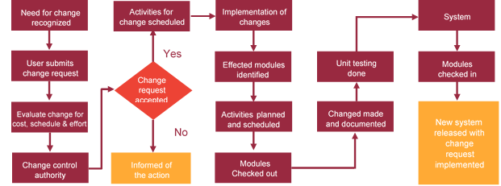

# Project Effort & Timeline

## Effort Estimate overview

The effort estimated for delivering the application as specified in section 2 will be as below:

|  |  |  |
| --- | --- | --- |
| **Activity** | **Effort (Man Days)** | **Delivery Days** |
| **Phase 1** | 49 | 28 |
| **Phase 2** | 29 | 19 |
| **Phase 3** | 30 | 20 |
| **Phase 4** | 30 | 20 |

## Effort Estimate Phase 1

|  |  |  |
| --- | --- | --- |
| **Activity** | **Effort (Man Days)** | |
| **Initiation** | | 09 |
| Requirements gathering and documentation (SRS) | |  |
| Functional Specification | |  |
| Finalizing and purchase of HTML Theme & Images | |  |
| Complete running prototype | |  |
| **Development & Testing** | | 38 |
| Registration, Login, Authentication | |  |
| Collaborations, Tasks, Team, Dashboard, Team View | |  |
| Testing & Bug fixing | |  |
| **UAT & Go Live** | | 02 |
| **Total Man Days** | | **49** |

## Effort Estimate Phase 2

|  |  |  |
| --- | --- | --- |
| **Activity** | **Effort (Man Days)** | |
| **Initiation** | 04 | |
| Requirements gathering and documentation (SRS) |  | |
| Functional Specification |  | |
| Complete running prototype |  | |
| **Development & Testing** | 23 | |
| Predefined & default Dashboards |  | |
| Dynamic & configurable Dashboard views |  | |
| Workspace | |  |
| Testing & Bug Fixing | |  |
| **UAT & Go Live** | | 02 |
| **Total Man Days** | | **29** |

## Effort Estimate Phase 3

|  |  |
| --- | --- |
| **Activity** | **Effort (Man Days)** |
| **Initiation** | 04 |
| Requirements gathering and documentation (SRS) |  |
| Functional Specification |  |
| Complete running prototype |  |
| **Development & Testing** | 24 |
| Filters for projects, Views & folders on  Share & un-sharing tasks, projects & folders with users, User groups. View permissions |  |
| Search Folders, Tasks, projects |  |
| Interactive & dynamic 'Gantt Chart with tasks, Dependencies, milestones |  |
| Duplicate tasks and subtasks |  |
| Testing & Bug Fixing |  |
| **UAT & Go Live** | 02 |
| **Total Man Days** | **30** |

## Effort Estimate Phase 4

|  |  |
| --- | --- |
| **Activity** | **Effort (Man Days)** |
| **Initiation** | 04 |
| Requirements gathering and documentation (SRS) |  |
| Functional Specification |  |
| Complete running prototype |  |
| **Development & Testing** | 24 |
| Dynamic reports (Dynamic and configurable reports that can be built from scratch) |  |
| Workload Views (Schedule tasks, Assign & Reassign tasks, set status) |  |
| Testing & Bug Fixing |  |
| **UAT & Go Live** | 02 |
| **Total Man Days** | **30** |

# Commercial

|  |  |
| --- | --- |
| **Description** | **Cost (USD)** |
| **Development of the Task Management Application** |  |
| Phase 1 | $ X,XXX.XX |
| Phase 2 | $ X,XXX.XX |
| Phase 3 | $ X,XXX.XX |
| Phase 4 | $ X,XXX.XX |

# Miscellaneous

## Warranty

Verbat shall provide a bug ﬁx warranty at no additional cost for 30 days from the date of acceptance of the project, for correction of any errors in the developed application that may be attributed to Verbat.

However, this does not cover modifications by Client, or use of the application on an environment other than the proposed environment, or other circumstances outside Verbat’s reasonable control. In such a case Verbat reserves the right to charge for its services.

All error corrections will be executed at Verbat India office. In the event of any need for on-site work, all expenses incurred for such trips will be payable to Verbat by Client.

## Acceptance Criteria

* UAT sign off should happen within 14 Days from the release of each module/ Phase and the acceptance confirmation needs to be mailed to Verbat failing which Verbat will consider the project as approved by the client
* Any comments or reason for rejection need to be documented and the same needs to be sent as an email from the official mail id of client to Verbat

## General Terms and Conditions

* Offer Valid for 30 calendar days from the date of submission of the Proposal
* An average of 20 working days are assumed in a month
* This proposal and all technical / functional specifications have been derived or concluded from the data shared via email / information's transferred during the initial requirement analysis meetings and conversations. Verbat reserves the right to amend the terms of this proposal, should the SOW terms, functional features and functionalities change during the course of the project
* The applications will be built as per the specifications agreed mutually. Any changes will be executed through a deﬁned change management process between both parties
* All Source Code and other project artefacts would adhere to the Verbat document templates and internal coding standards
* Acceptance criteria shall be based on the clauses which were mutually discussed between Verbat and client at the Requirement Analysis phase and the same will be documented and approved by both parties through official emails
* Final deployment to production server pursuant to completion of all payments

## Assumptions and Dependencies

* During the requirement gathering phase, authorized personnel from the Client’s side is expected to be available for discussion and finalizing the HLD (High Level Design), before development commences.
* Type of reports and formats, if under the scope of the project, needs to be specified by Client before project sign off.
* Workflows need to be specified/ confirmed by client before project signoff.
* All queries regarding the client requirement and any queries which may hinder the project advancement at any stage should be answered by the client within 24 hours from the time of initiation, failing which the time delay will get added to the actual effort which was estimated.
* Verbat assumes that all sign-offs from Client will be provided within agreed and specified timeframe.
* Client will provide all the necessary contents, both text and image, before starting the project in the format suggested by Verbat (if any).
* The client should provide the relevant information and data well in time for the execution of a related activity. Non- availability of this information or data may lead to an interruption of work which may result in a delay in delivery as well as additional costs to the client.

## Source Code & Intellectual Property Rights

* Upon completion of the Project and 100% completion of the payment, client will have access to the source code except for propriety codes, developer tools and third party application / modules like Microsoft Dynamics Products, Share Point LMS etc.
* The solution offered will be the intellectual property of the client and will be made available to the client on an “unlimited license” basis.
* Modifications by third party/person: No person or organization, other than Verbat or any person authorized by Verbat in writing, has any permission to modify/change the software Solution to be eligible to get continued support from Verbat as per the support terms defined under this document.
* Liabilities/Damages: Verbat accepts no liability or damages of any kind arising out of use or non-use of the software delivered. The responsibility of testing of software lies with Client.

# Our Clients

**UAE University**

Education

Transportation

**Canada Cartage**

Construction

Services

We look forward to hearing from you soon and hope that you will give us the privilege to work with you in meeting your business goals. Thank you.

Thank You



©   
1999 - 2017. All Rights Reserved   
Verbanet Technologies LLC  
www.verbat.com